NAME: ______________________________

CECIL ANDREWS COLLEGE
ATAR Human Biological Science Unit 3

HOMEOSTASIS

QUESTION/ANSWER BOOKLET

STRUCTURE OF THIS PAPER:

Section | Number of questions available | Marks allocated | Your Marks
Multiple Choice | 10 | 10
Short Answer | 4 | 40
Extended Answer | 1 | 10

MARK / 60

MARK: _______________________%

CECIL ANDREWS COLLEGE
ATAR Human Biological Science Unit 3

HOMEOSTASIS

Place a X through the best answer.

1 |  | (a) | (b) | ( c) | (d)
2 |  | (a) | (b) | ( c) | (d)
3 |  | (a) | (b) | ( c) | (d)
4 |  | (a) | (b) | ( c) | (d)
5 |  | (a) | (b) | ( c) | (d)
6 |  | (a) | (b) | ( c) | (d)
7 |  | (a) | (b) | ( c) | (d)
8 |  | (a) | (b) | ( c) | (d)
9 |  | (a) | (b) | ( c) | (d)
10 |  | (a) | (b) | ( c) | (d)

Section B Short Answer Questions

11. This question refers to the table below giving the concentrations of glucose in the blood taken from an individual during a 5 hour period. At the start of recording, and for a further 90 minutes, blood glucose level was within normal limits. Following a meal the glucose levels increased, then decreased back to normal levels within 90 minutes. This individual then went for a one hour run. During this one hour run, blood levels decreased and remained low for a further 60 minutes.

Time (Minutes) | Blood glucose concentration (mg/100mL)
0 | 100
30 | 95
60 | 100 (glucose concentration normal)
90 | 105 (following meal)
120 | 150
150 | 120
180 | 100 (started a 1 hour run)
210 | 95
240 | 75 (end of 1 hour run)
270 | 70
300 | 75

a. Using the above data plot the changes in the blood glucose levels over time.

(6 marks)

b. If respiration is constantly using up glucose why did the glucose concentration in the blood remain relatively constant during the first 90 minutes? (1 mark)
________________________________________________________________________________
________________________________________________________________________________
c. State two reasons why glucose concentration the blood rose after the meal?
(2 marks)
________________________________________________________________________________
________________________________________________________________________________

d. Why did glucose concentration in the blood decrease during the one hour run?
(1 mark)

_______________________________________________________________________________
_______________________________________________________________________________

e. Predict what the glucose concentration would be 2 hours after the run if no more food was eaten. (1 mark)

12. A biologist is studying animal life in Antarctica, where the average daily temperature is -50 ̊C. His work requires him to be in the open air making observations over long periods of time.

  - Describe ONE behavioural modification he would need to make, apart from wearing warmer clothing, when outside observing animals. (1 mark)

  - Physiological mechanisms are also essential for the scientist to maintain his core temperature in these freezing conditions.

Name two (2) mechanisms that his nervous system would control and explain how they would maintain his core temperature (2 marks)

  - What is the modulator for body temperature? (1 marks)

_______________________________________________________________________________

  - Two other biologists are studying other animal species in completely different conditions to that in Antarctica. One is in a hot desert and the other is in a tropical rainforest. Both climates have a similar average daily temperature of 34 ̊ C. However, the biologist in the desert feels relatively comfortable whereas the one in the tropical rainforest finds it very uncomfortable. Explain why? (1 marks)

  - After a period of time without nourishment, the blood volume of the biologist in the desert would change more than that of the biologist in the tropical rainforest.

- Describe the change that would occur to the biologist in the desert. (2 marks)

ii. Explain your answer to part (d) (i) (1 mark)

- Explain how this change could affect his actual blood pressure. (2 marks)

13. Experiments were carried out in which a naked person was asked to sit in a room while the temperature around them was gradually lowered and raised. Tests were conducted in environmental temperatures between 0oC and 40oC. The graph below shows a generalised graph of what happened, with extrapolations beyond the actual temperatures tested.
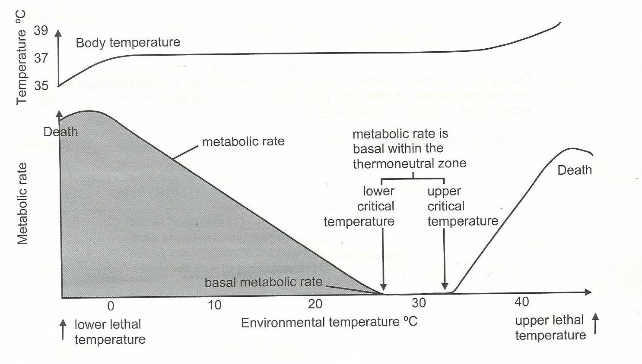

- What changes in behaviour could influence metabolic rate below the lower critical temperature? (2 marks)

b) Why would the production of thyroxine change with a change in environmental temperature from 10oC t0 25oC? (2 marks)

c) State two methods of heat loss from the body within the thermoneutral zone.
(2 marks)

d) How would environmental conditions other than temperature affect heat loss at temperatures above the upper critical temperature? (2 marks)

e) During the experiments carried out above 35oC, the volume of urine produced was less and the concentration of the urine was greater than that of the urine produced during the experiments conducted in the themoneutral zone.

Explain why this would happen. (3 marks)

14. An investigation was carried out into the effects of exercise on the heart rate and breathing rate of a student. Her hear rate, breathing rate and blood pH were first measdured at rest. Data were collected after she had cycled for 2 minutes at 5 km/hr on an exercise bicycle. After resting for 5 minutes, the procedure was repeated at cycling speeds of 10, 15,20 and 25 km/hr. The results are shown in the table and graph below.

Cycling Speed (km/hr) | Heart rate (beats/min) | Breathing rate (breaths/min)
0 | 64 | 12
5 | 70 | 13
10 | 80 | 14
15 | 100 | 17
20 | 140 | 20
25 | 180 | 27

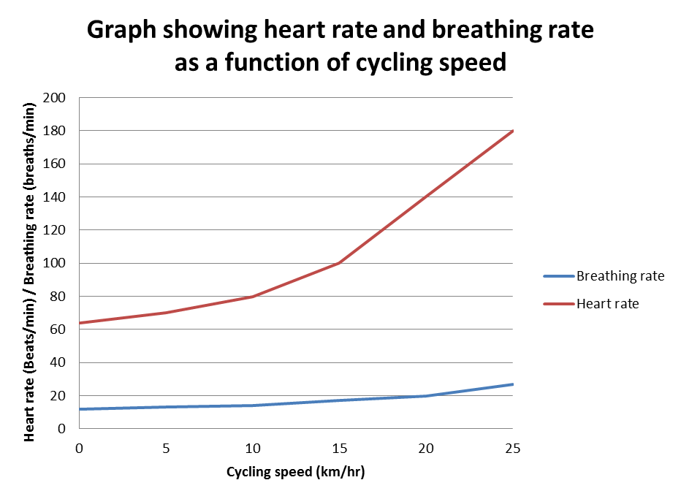

- Describe the relationship between cycling speed and heart rate. (1 mark)

b) Explain the changes in breathing rate as the cycling rate increased. (3 marks)

c) During the investigation, the student was given a 5 minute rest between each 2-minute cycling session. Suggest why this was done. (1 mark)

d) The student in this investigation had blood samples taken before any cycling activity and at the end of the investigation. The pH was measured for both samples and it was found that the pH had dropped from 7.4 to 7.2 during the investigation

Explain why this change would have occurred. (3 marks)

Section C – Extended Answer - 10 marks
15. Susarnah was part of a research group investigating the control of blood glucose levels in different people. The graph below shows the changes in her blood glucose levels over a period of 24 hours.
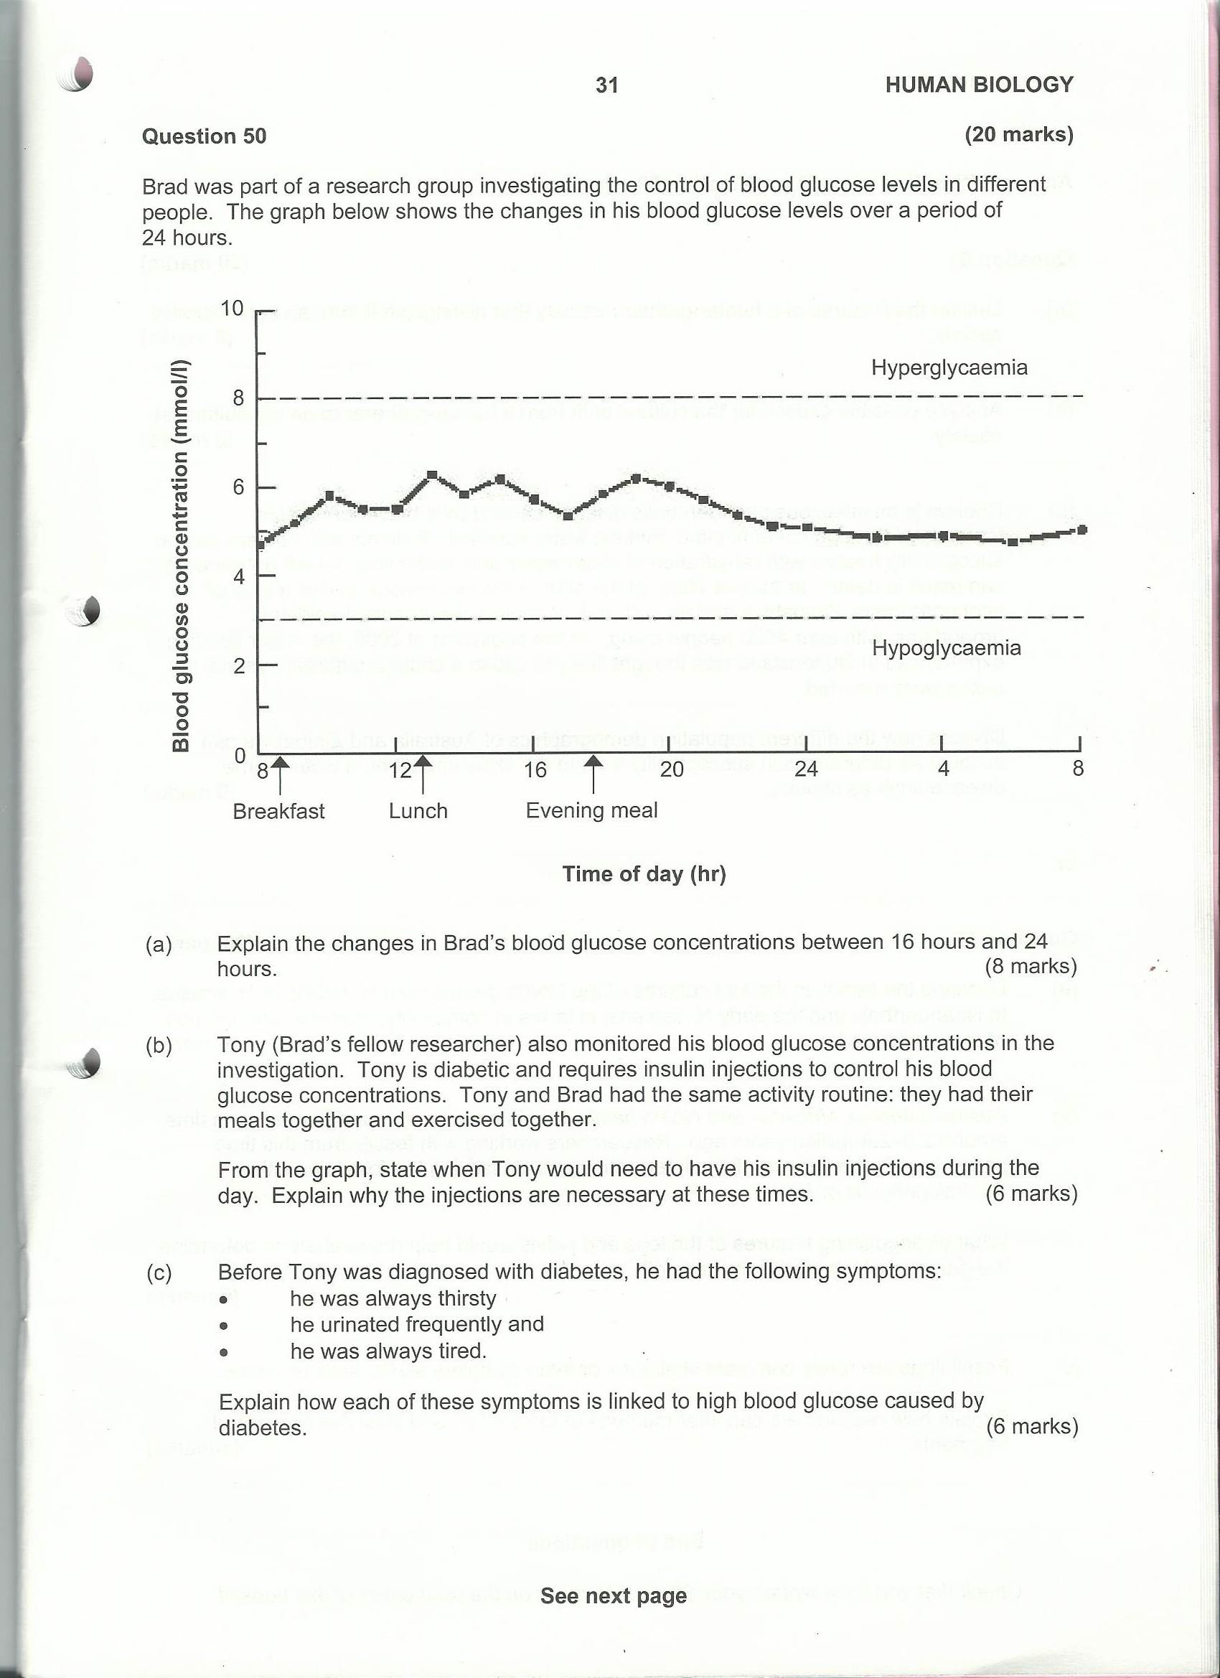

(a) Kasa (Susarnah’s fellow researcher) also monitored her blood glucose concentrations in the investigation. Kasa is diabetic and requires insulin injections to control her blood glucose concentrations. Kasa and Susarnah had the same activity routine: they had their meals together and exercised together.
From the graph, state when Kasa would need to have her insulin injections during the day. Explain why the injections are necessary at these times. (6 marks)

Before Kasa was diagnosed with diabetes, she had the following symptoms:
- she was always thirsty
- she urinated frequently
- she was always tired
Select two of these symptoms and explain how each is linked to high blood glucose caused by diabetes. (4 marks)

Acknowledgements
Q 9. Figure adapted from SCSA Tertiary Entrance Examination, 2009, Question Answer Booklet, pg 7
Q 13. Figure adapted from SCSA Tertiary Entrance Examination, 2009, Question Answer Booklet, pg 21.
Q 15. Figure adapted from SCSA Tertiary Entrance Examination, 2009, Question Answer Booklet, pg 31.

